SIS-CERS Student Group Integration: Utilizing AWS Cognito Authorization

This document is intended for Student Information Services (SIS) vendors for use with local educational agencies regarding the set-up of automated updating of student group information from SIS into the California Educator Reporting System (CERS).

Overview of Steps
The following information provides an overview of steps that leverage the usage of a Cognito Authorization Token and Postman to perform the data update and verify authorization and connectivity to the Application Programming Interface (API). This information can be used in partnership with local educational agencies as a solution for allowing an SIS vendor to automate student group information updates to CERS and will leverage the same authorization information that is used for the Student Score Report to obtain the authorization token.

The steps are:
- Get Username and Password for the Student Score Report
- Obtain the AWS Cognito Authorization Token
- Compile the Student Group information for upload (in the correct format)
- Submit an API request, attaching the token information and data
- Confirm submission

Step Information
Steps 1 and 2 are the steps that are used to obtain a token for the student score report. Complete documentation for that process can be obtained at:
https://www.caaspp.org/administration/reporting/student-score-report-option-A.html

Step 1

Get Username and Password
Please see the documentation located at: http://www.caaspp.org/administration/reporting/student-score-report-option-A.html.

Step 2

Get Authorization Token
Please see documentation provided at: https://www.caaspp.org/rsc/pdfs/CAASPP.ELPAC.Application-Program-Interface-to-Electronic-Score-Reports.2020-21.docx

Step 3

Compile Student Group File
The roster information from your SIS should be compiled in alignment with the specifications located on the Student Groups documentation. The table below is from the documentation and shows the values expected in the Student Group file.

Field | Data Type | Description
group_name* | text | Group name
school_natural_id* | text | School id
school_year* | integer | School year, e.g. 2023 for 2022-23
subject_code | text | All, Math, ELA, etc. (Can only be one)
student_ssid | text | Student ssid
group_user_login | text | User login
*Denotes required and key fields

Note: It is suggested that SIS Vendors consult with CDE to verify the District and School ID values that are utilized within the Reporting Data Warehouse as they may differ from the format that SIS vendors typically use.

Step 4

Submit via the API
Submit an API request using the Cognito-Authorized token and the roster information to the API. The URL for the request should be submitted to the following Production URL Endpoint: https://groups.import.smarterbalanced.org/groups/imports/

- Documentation for Uploading using the API can be found in the RDW API repo

Step 5

Confirm Submission
Confirmation of a successful transmission should be received. Log and note any errors. Troubleshooting will need to be performed locally.

Successful Submission Result Screen: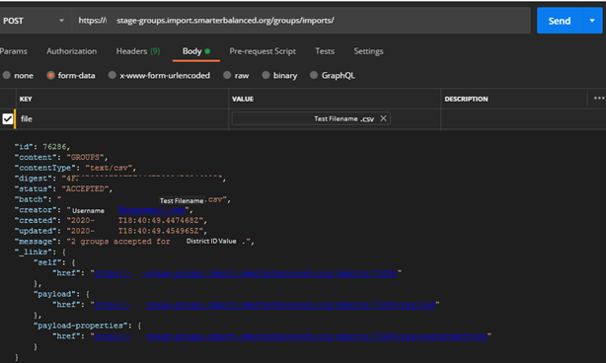

Note: The ability to check the status via the Payload URL is for administrators only at this time.

Helpful Information

Contact for Assistance
Please visit the Get Answers page or visit https://www.caaspp.org/administration/reporting/sis-vendor-integration.html if you are experiencing any issues.

Frequently Asked Questions
Below are frequently asked questions and answers that may assist when developing a solution to utilize the Student Group API via Cognito Authorization.

Question: How many students can be uploaded in a single file at a time?
Answer: A maximum of 200,000 rows of student data. Allow for approximately 5-10 minutes for processing for a file this size.

Question: What is the limit of number of students assigned to a student group?
Answer: No. A maximum of 200 students per Student Group assignment still is in place.

Question: What is the naming convention for Student Group?
Answer: Student Group names must be composed of alpha-numeric characters (underscores and hyphens are also accepted, spaces are not acceptable) and no greater than 100 characters in length.

Question: Do groups all need to be sent grouped by school?
Answer: All schools must be grouped. For example, the system would incorrectly assign students if a submission had students assigned to a group for SchoolA and then a group for SchoolB then returned sequentially to a group for SchoolA. All students in SchoolA should be grouped within a file submission.

Question: Will the API process the same file over and over?
Answer: Regardless of if a file submission is successful or fails, if the same file is utilized without alteration the service will not process the file. It will assume it is the same file and to avoid an accidental repeat it is not processed. The data in the file is examined prior to ingestion and assigned a metatag that allows the system to identify if it has attempted to upload the file before. Filenames will not make a difference. Alteration of a single field will trigger the import to run as it identifies updated data.

Question: If a data exists in the file submission, does the entire submission fail or just the section where the error exists?
Answer: An error will cause the entire submission to fail.

Question: Is it possible to upload only new students added for a particular Student Group?
Answer: The Student Group upload is a delete and replace solution, per Student Group. For example, if a set of students is uploaded using a pre-existing Student Group name, the new students will replace any existing students assigned to that Student Group. However, it is possible to only update an individual Student Group for an individual school.

Verify Authorizations
If you are receiving authorization issues, please attempt to verify your authorization by inserting the Bearer token information via a ‘GET’ at the following URL. Supply this information in your support request ticket.

Verify Access URL: https://groups.import.smarterbalanced.org/imports/user

Testing Your Solution
Testing to verify that Student Group information is accurately being updated by a solution developed by an SIS Vendor must be done within the CERS Production environment. This is because the Cognito Token is only authorized to access the production environment.
To test, a recommended approach would include a coordinated effort between the SIS Vendor and an interested entity, such as a specific institution or a district that has direct access to validate data on the front-end within CERS.

First, leveraging a tool like Postman to verify credentials and establishing the connection is recommended. Next, using the specs outlined for the data, create a file for upload that contains one student group and assign that to the educator assisting in the test. The educator would then be able to quickly validate the information in the CERS application. To then remove the assignment, the same group could be submitted with a now empty set of information (i.e. the student_ssid and group_user_login fields should be empty). Remember, the key fields that must be present for updating student groups are always group_name, school_natural_id, and school_year. This should be enough to validate the test.

File Examples
1 group - 1 subject - 1 teacher:
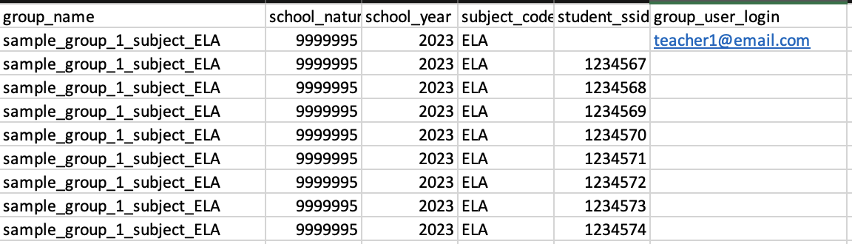

1 group – 1 subject - 2 or more teachers:
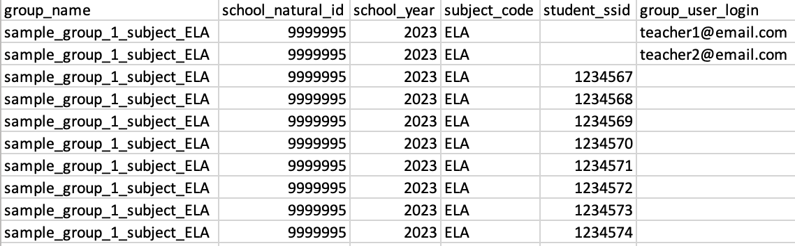

2 groups – 2 subjects - 1 teacher: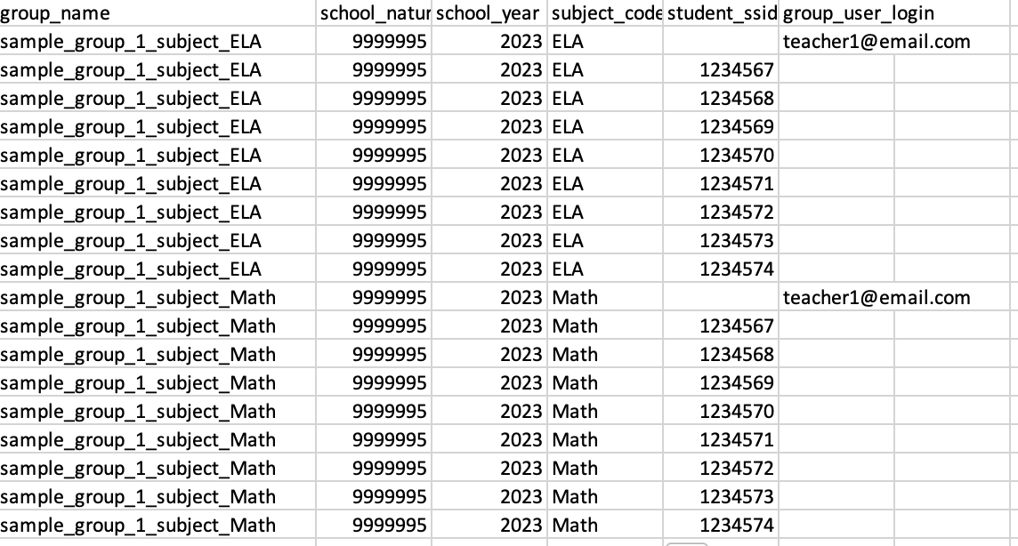

2 groups – 2 subjects -2 or more teachers:
