California Alternate Assessment for Science

Directions for Administration Training Performance Task
Fossils and Plate Tectonics
  - Table of Contents
About the Directions for Administration 1
Additional Information 1
Using the Directions for Administration 1
Alternative Text for a Student with Visual Impairment 2
Entering Student Responses 2
Videos 3
Assessed Standards 4
Activity 1 Science Connector: 3-LS4-1—Biological Evolution: Unity and Diversity 5
Activity 2 Science Connector: HS-ESS1-5—Earth’s Place in the Universe 5
Individualization 6
Preparation for the Orienting Activities 7
Orienting Activity 1—Fossils 7
Individualization of the Orienting Activity—Fossils 7
Orienting Activity 2—Plate Tectonics 8
Test Administration Scripts for the Embedded Performance Task 9
Script for Orienting Activity 1—Fossils 9
Scripts for Orienting Activity 1 Test Questions 10
Script for Orienting Activity 2—Plate Tectonics 13
Scripts for Orienting Activity 2 Test Questions 14
Appendix A: Summary of Materials 17
Appendix B: Graphics 18

About the Directions for Administration
This Directions for Administration (DFA) document contains information needed by test examiners to prepare for and administer the online California Alternate Assessment (CAA) for Science training performance task, including orienting activities and scripts to read aloud to the student.
The purpose of the online CAA for Science training performance task is to familiarize students and test examiners with the test interface, item types, and overall structure of the embedded performance tasks (PTs). The training performance task represents the length and typical question types found in a single embedded PT. Note the training PT does not produce a score.
This training PT is available all year and may be used at any time in preparation for the online CAA for Science assessments in grades five and eight and high school.
Online training tests can be administered in one of two ways:
- Using the same procedures as the annual assessments, with the Test Administrator Interface, secure browser, and individual student logon information;
or
- Using a standard, supported web browser to access the training tests directly, without use of the Test Administrator Interface or secure browser.

Additional Information
- How to Start a Test Session for the CAAs web document—https://www.cde.ca.gov/ta/tg/ca/documents/caatestsessionqrg.pdf
- California Alternate Assessments web page—http://www.caaspp.org/administration/about/caa/

Using the Directions for Administration
This DFA contains a script for administration of a CAA for Science embedded PT. Keyword instructions for test examiners will be as follows:
Instruction in the DFA | How the Test Examiner Should Proceed
SAY | The test examiner reads the material out loud to the student.
POINT to the flowers. | The test examiner points to the information on the screen.
READ each option and POINT TO  or  POINT TO and SAY | What is the total number of flowers?  The test examiner reads each option on the screen out loud while pointing to the information on the screen.
DO | The test examiner performs an action.  Actions are listed as bullet points.

Alternative Text for a Student with Visual Impairment
Within the DFA is a column that provides Alternative Text for a Student with Visual Impairment. The alternative text in this column should be used to describe images for a student who is not able to fully access the images or videos used in the assessment.
The alternative text is intended to be a supplement to the administration script and should not be used in place of the administration script. Where the administration script prompts a test examiner to “POINT TO” an image, the test examiner would instead read the relevant alternative text to the student. The alternative text can be repeated based on a student’s need or request. The alternative text should be read exactly as it is written in the DFA, without clarification or rephrasing.

Entering Student Responses
The CAAs are designed for one-on-one administration between a student and a test examiner familiar with the student. When able, students provide responses directly into the testing device. In some cases, the test examiner selects the responses indicated by the student by means that may include, but are not limited to gesture, eye gaze, and an alternative communicative device. In all cases, responses must come from the student and not from the test examiner. Hand-over-hand or other physical prompting by the test examiner is not permitted.

Videos
Videos are sometimes used to provide demonstrations of scientific phenomena in the CAA for Science. These videos do not contain audio. Some videos contain text the test examiner must read to the student.
Videos may be paused or replayed as many times as needed. A student or test examiner may change the playback speed (i.e., 0.5X, 1X, 1.5X, and 1.75X) on the progress bar as necessary to ensure the student is able to process the content.

Assessed Standards
Resources in This Section:
- CAASPP California Alternate Assessments (CAAs) web page—http://www.caaspp.org/administration/about/caa/
- California Department of Education (CDE) California Alternate Assessment for Science web page—https://www.cde.ca.gov/ta/tg/ca/caascience.asp
- CAA for Science Blueprint web document—https://www.cde.ca.gov/‌ta/tg/ca/documents/caascienceblueprint.docx
The CAA for Science Core Content Connectors (Science Connectors) assessed in this training performance task (PT) are provided here for your reference. For purposes of demonstration and training, two grade spans have been selected for this training PT.
The science standards measured in each annual administration of the CAA for Science are provided in administration planning guides, which can be found on the CAASPP California Alternate Assessments web page.
Each CAA for Science embedded PT measures two Science Connectors, which are further broken down into more discrete focal knowledge, skills, and abilities (FKSAs); and, at the simplest level, the essential understandings (EUs). Each embedded PT contains two orienting activities and 10 test questions from just one science domain, such as the Life Sciences.
The science concepts presented and assessed in this training PT closely represent the type of content assessed on the CAA for Science.
The complete CAA for Science content standards can be found in the CAA for Science Blueprint web document. See also the CDE California Alternate Assessment for Science web page for more information about the CAA for Science.

Activity 1 Science Connector: 3-LS4-1—Biological Evolution: Unity and Diversity
Using data, through observation, recognize that fossils represent plants and animals that lived long ago.
Feature | Definition | Students Will Be Able To …
FKSA | Ability to use data through observation to recognize that fossils represent plants and animals that lived long ago. | - Match pictures of fossilized organisms to related living organisms.
EU | Match an extinct organism to its habitat. | - Match pictures of fossilized organisms to their habitats.

Activity 2 Science Connector: HS-ESS1-5—Earth’s Place in the Universe
Identify the relationship between the motion of continental plates and how materials of different ages are arranged on Earth’s surface.
Feature | Definition | Students Will Be Able To …
FKSA | Ability to identify the relationship between the motion of continental plates and how materials of different ages are arranged on Earth’s surface. | - Identify the relationship between the motion of continental plates.  - Indentify how materials of different ages are arranged on Earth’s surface.
EU | Identify that the Earth has continental and oceanic crusts. | - Recognize continental crust.  - Recognize oceanic crust.

Individualization
All items may be individualized based upon the student’s IEP. This DFA provides test examiners with guidelines on how to individualize the orienting activities and designated items.
Like other standardized assessments, the CAA for Science should be administered to each student in a consistent manner according to the directions provided, with variations only as specified in each student’s IEP. However, to maximize engagement for all students, the CAA for Science sometimes offers additional options for individualization in specific orienting activities and test questions.
This DFA does not specify additional individualization options. Individualization based on the student’s IEP is permitted. The student should carry out activities to the greatest extent possible, but if the student is unable to do so, the test examiner should manipulate the materials to conduct the activity.

Preparation for the Orienting Activities
The orienting activity readies the student for the actual test questions. The orienting activity introduces concepts covered in the embedded PT.
As the test examiner, you may substitute objects that are more familiar to the student for this activity.
A summary of all materials that may be needed for this embedded PT can be found on page 17 in appendix A.

Orienting Activity 1—Fossils
The purpose of this activity is for the student to compare the features of a fossilized animal to the features of two modern animals in order to determine relatedness.
In this recommended orienting activity, students will identify a modern animal that is related to a fossilized animal.

Individualization of the Orienting Activity—Fossils
Different materials may be used to conduct the activity. If you are going to use one of the possible substitutes, you must gather the materials before you begin testing.
As the test examiner, you may substitute graphics that are more familiar to the student for this activity. In this activity, pictures of fossils, modern animals, and environments that are more familiar to the student may be used. To make a decision about which materials to use, review the activity on page 9 of the DFA.
Exemplar Material | Optional Materials for Individualization
Cut out graphics 1–3 in appendix B starting on page 18 | - Select a picture of a fossil that is familiar to the student and has clearly identifiable physical traits.  - Select two pictures of two modern animals that are familiar to the student and have clearly identifiable physical traits; one of the animals must be related to the fossil.

Orienting Activity 2—Plate Tectonics
The purpose of this activity is for the student to observe the effect of tectonic plate movement on the locations of oceans and land masses on Earth.
In this orienting activity, students will observe diagrams showing the locations of oceans and continents at different periods in Earth’s past.

Test Administration Scripts for the Embedded Performance Task
Log the student on to the test delivery system now, before starting the first orienting activity. (Note: orienting activities sometimes make use of graphics or other manipulatives that are external to the test delivery system, and sometimes use videos or graphics that are within the test delivery system.)

Script for Orienting Activity 1—Fossils
Administration Script | Alternative Text for Students with Visual Impairments
SAY:We are going to look at a fossil and pick which animal is related to the fossil animal.  DO:  Place Graphics 2 and 3 side by side.  Place Graphic 1 centered beneath them.  POINT TO Graphic 1 and  SAY: This shows a fossil of an animal with a long tail and four legs. Let’s decide which animal is related to this fossil.  POINT TO the snake and  SAY:  This animal has a tail, but does not have any legs.  POINT TO the lizard and  SAY:  This animal has a tail and it has four legs. It is related to the fossil.  DO:  Move the fossil directly below the picture of the lizard. | None

Optional Individualization | Alternative Text for Students with Visual Impairments
Pictures of animals and fossils that have been used during instruction may be used in place of the provided graphics. | DESCRIBE:  Follow the process described in the administration script, describing the features of the fossils being shown.
This concludes Orienting Activity 1. Now begin testing following sequence No. 1 through 5, which correspond to on-screen sequence numbers.

Scripts for Orienting Activity 1 Test Questions

No. 1
Administration Script | Alternative Text for Students with Visual Impairments
POINT TO the fish fossil and  SAY:  This shows a fossil with fins.  READ the item, POINT TO the options, and SAY the following:  deer  fish | None

No. 2
Administration Script | Alternative Text for Students with Visual Impairments
POINT TO the tiger fossil and  SAY:  This shows a fossil with long, sharp teeth.  READ the item, POINT TO the options, and SAY the following:  tiger  turtle | None

No. 3
Administration Script | Alternative Text for Students with Visual Impairments
SAY:  We will look at some fossils and decide where they lived.  POINT TO the fossil and SAY:  This shows a fossil with long legs.  READ the item, POINT TO the options, and SAY the following:  ocean  dry, grassy field | None

No. 4
Administration Script | Alternative Text for Students with Visual Impairments
SAY:  We will look at some fossils and decide where they lived.  POINT TO the fossil and SAY:  This is a fossil of an animal that lived long ago.  READ the item, POINT TO the options, and SAY the following:  pond  rainforest | The picture shows an animal with fins.  The picture shows a pond.  The picture shows a rainforest with lots of tall trees and large plants.

No. 5
Administration Script | Alternative Text for Students with Visual Impairments
POINT TO the fossils and SAY:  When these fossil animals were alive, they lived in very different places.  POINT TO each place and SAY:  This is a picture of a dry, grassy place.  This is a picture of a pond.  READ the item,  POINT TO the first fossil and SAY the following:  This picture shows an animal with long legs and webbed feet. Show me where this animal lived.  POINT TO each place and SAY the following:  In a dry, grassy place  In a pond  POINT TO the second fossil and SAY the following:  This picture shows an animal with long legs and feet with hooves.  POINT TO each place and SAY the following:  In a dry, grassy place  In a pond | The picture shows an animal with long legs and webbed feet.  The picture shows an animal with long legs and feet with hooves.
This concludes the first half of the embedded PT. Have materials and preparation ready for Orienting Activity 2 before proceeding.

Script for Orienting Activity 2—Plate Tectonics
Administration Script | Alternative Text for Students with Visual Impairments
DO:  Place Graphic 4 (image of the continents when they were Pangaea), Graphic 5 (image of the continents from 100 million years ago), and Graphic 6 (image of continents from today) in front of the student  POINT TO Graphic 4 and SAY:  This is a picture of Earth from 225 million years ago.  POINT TO Graphic 5 and SAY:  This is a picture of what Earth looked like 100 million years ago.  POINT TO Graphic 6 and SAY:  This is a picture of what Earth looks like today. It is the same planet but it looks different because the continents moved over time. The continental plates have moved, causing the continents to move too. This is why one super continent is now seven separate continents. | DESCRIBE:  (Graphic 4) The picture shows Earth from 225 million years ago. All of the continents are together in the middle of the map.  (Graphic 5) The picture shows Earth from 100 million years ago. The continents have split apart and have moved away from each other.  (Graphic 6) The picture shows Earth today.

This concludes Orienting Activity 2. Continue testing following sequence No. 6 through 10, which correspond to on-screen sequence numbers.

Scripts for Orienting Activity 2 Test Questions

No. 6
Administration Script | Alternative Text for Students with Visual Impairments
READ the item, POINT TO the options, and SAY:  A  B | DESCRIBE:  The picture shows Earth’s crust with the ocean above it.  The picture shows Earth’s crust with a forest above it.

No. 7
Administration Script | Alternative Text for Students with Visual Impairments
POINT TO the picture, READ the labels and SAY:  This shows two pieces of crust.  READ the item and POINT TO each option as it is read. | DESCRIBE:  The picture shows two pieces of Earth’s crust moving together. The left crust has a continent. The right crust has an ocean. There are arrows under the right crust pointing to the left and going under the left crust.There is an arrow under the left crust pointing to the right.

No. 8
Administration Script | Alternative Text for Students with Visual Impairments
READ the item, POINT TO the options, and SAY:  a valley  a mountain  a crack in the ocean crust | DESCRIBE:  The picture shows a valley between two mountains.  The picture shows a mountain.  The picture shows the ocean floor cracking,with magma coming out.

No. 9
Administration Script | Alternative Text for Students with Visual Impairments
SAY:  Now we will watch a video.  PLAY the video and READ the script below.  This shows where two pieces of the ocean crust are moving apart forming a volcano. Lava is coming out where the pieces are pulling apart.  READ the item and POINT TO each option as it is read. | DESCRIBE:  The video shows the ocean crust moving in opposite directions. There is lava where the pieces are separating.

No. 10
Administration Script | Alternative Text for Students with Visual Impairments
Part A  READ the item and POINT TO each option as it is read.  If necessary prompt the student to respond to each part:  SAY:  Where is the younger crust? Where is the older crust?  Part B  READ the item, POINT TO each option as it is read. | DESCRIBE:  The picture shows the ocean crust with a crack in it. There is lava coming out of the crack. On one side of the ocean crust is continent crust. There is a blank box by the lava coming out of the crack. There is a blank box on the continent rock.  The label says younger crust.  The label says older crust.  The picture shows two arrows pointing at each other.  The picture shows two arrows pointing away from each other.

Appendix A: Summary of Materials
This appendix contains a summary of the materials that may be needed to individualize orienting activities or test questions for specific students.
Student Interaction | Page | Exemplar Materials | Optional Materials for Individualization
Orienting Activity 1—Fossils | 9 | Graphics 1–3 in appendix B starting on page 18 | - Picture of a fossil that is familiar to the student and has clearly identifiable physical traits  - Pictures of two modern animals that are familiar to the student and have clearly identifiable physical traits; one of the animals must be related to the fossil
Orienting Activity 2—Plate Tectonics | 13 | Graphics 4–6 in appendix B starting on page 18 | - None

Appendix B: Graphics
Cut along the dotted lines.

Graphic 1
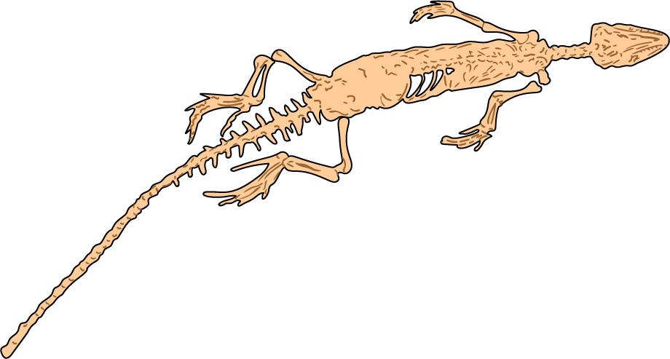

Graphic 2
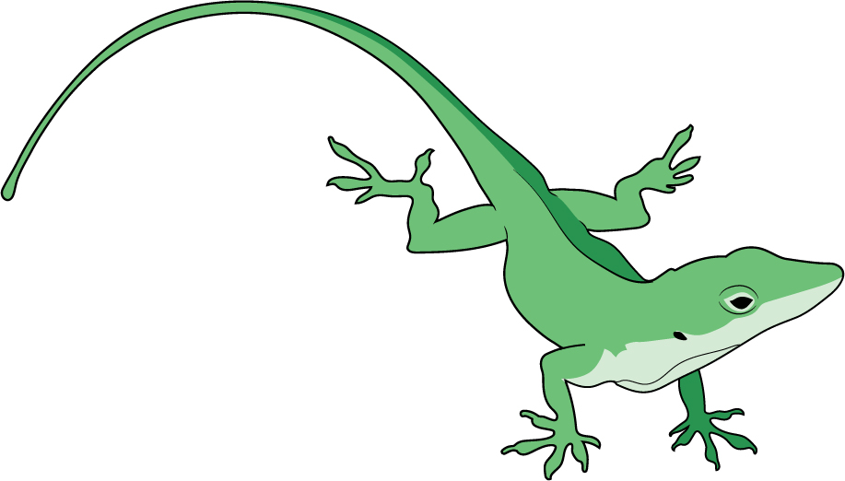
This page is intentionally left blank.

Graphic 3
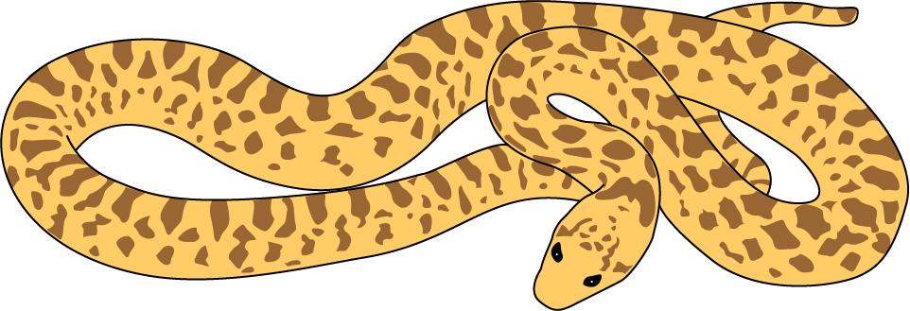

This page is intentionally left blank.

Graphic 4
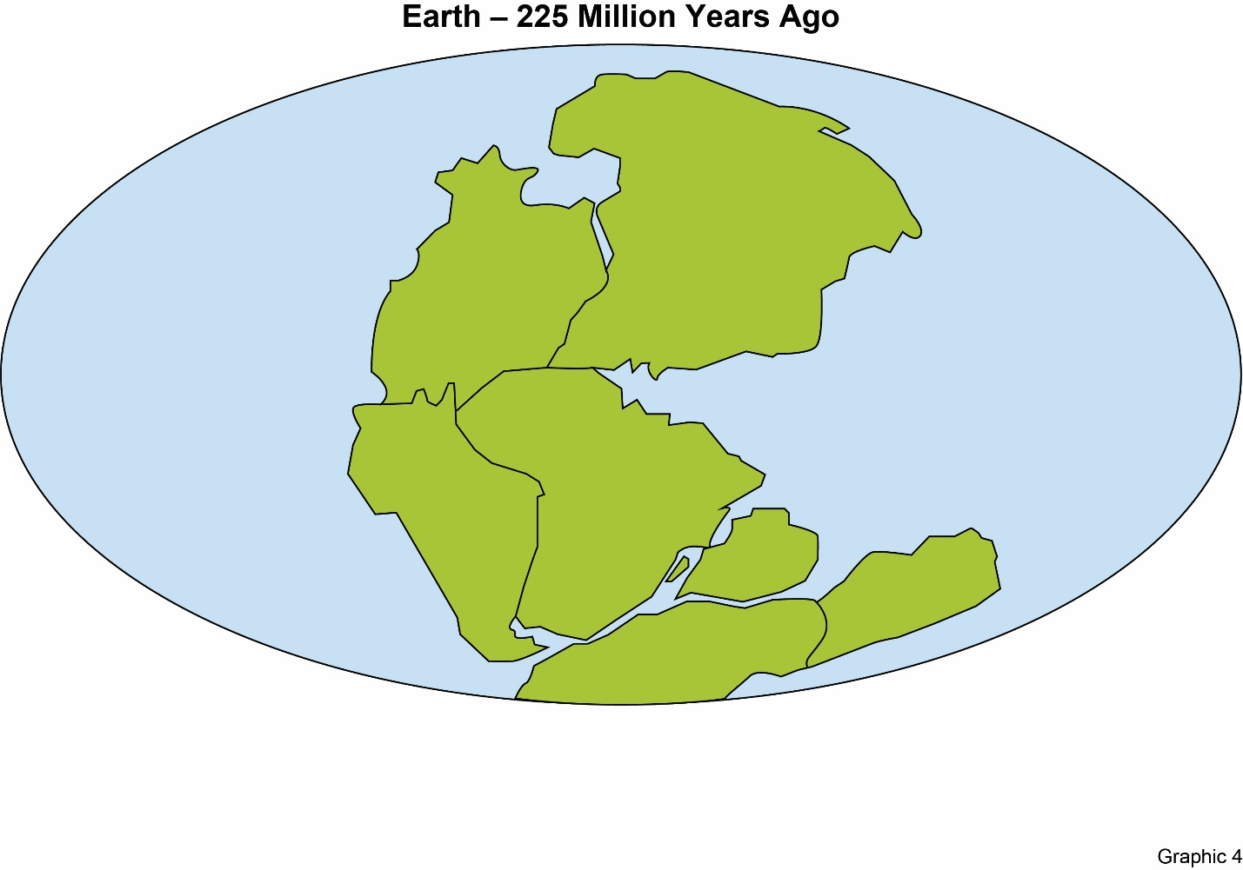
This page is intentionally left blank.

Graphic 5
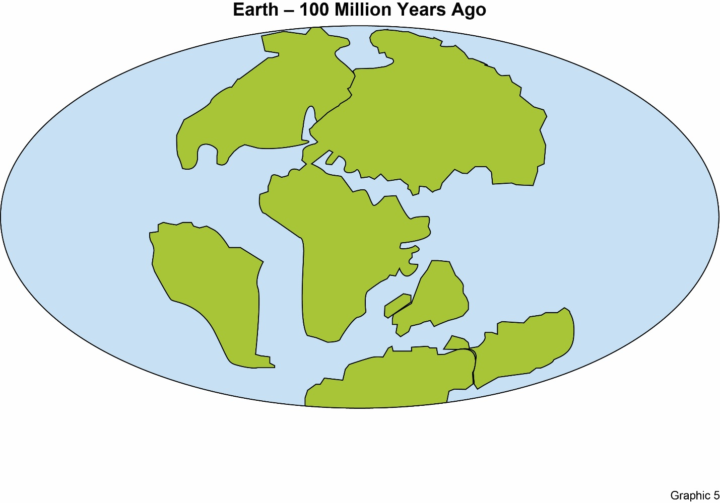
This page is intentionally left blank.

Graphic 6
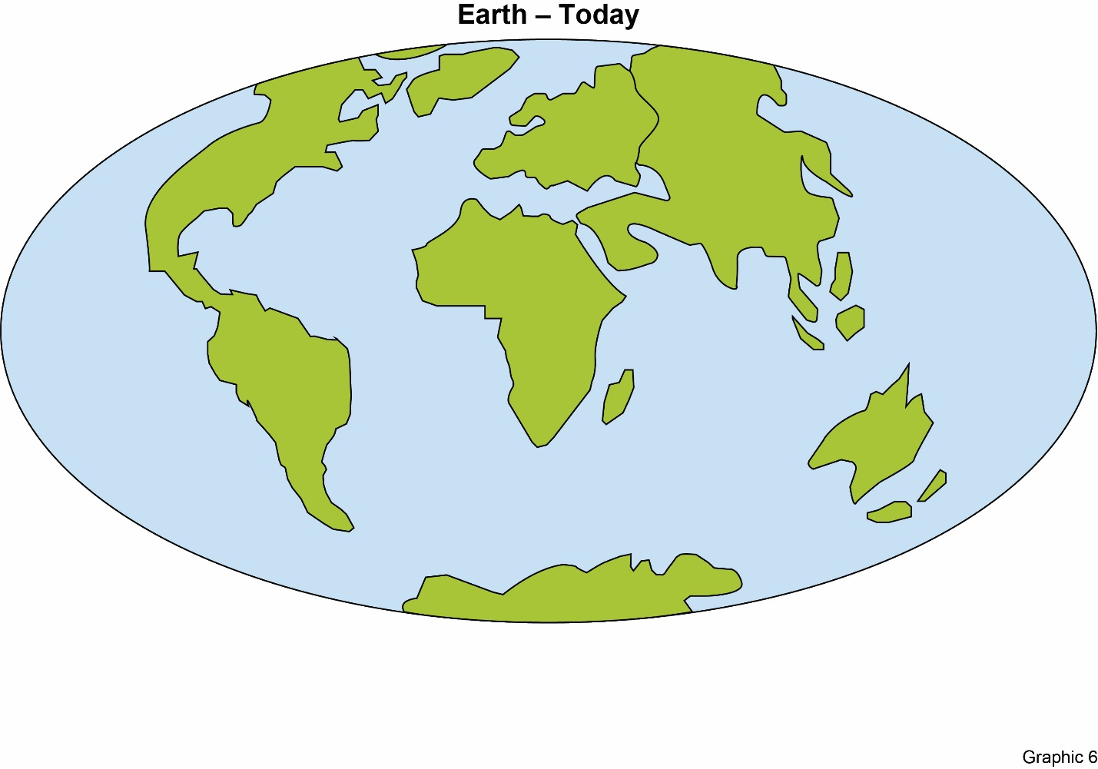
– END –

