Matching Accessibility Resources to Students’ Needs

Notetaking Guide
September 2022
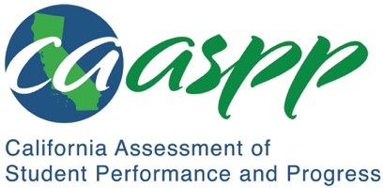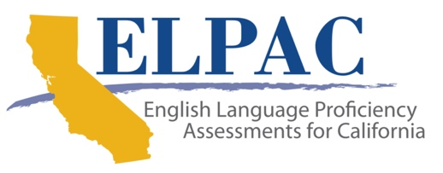

Why Use Accessibility Resources?
- Reflection
- Which version of the test yields the more accurate score—the paper version or computer version?
- Which provides Patrick’s teacher, Mr. Hernandez, with more helpful information?
- Which is fairer?

What Are Accessibility Resources?
- Which principle fits “breaks” best?
- Which principle fits “read aloud” best?

How to Match Accessibility Resources to Students’ Needs
- What are Marco’s strengths that can help us think about needed accessibility resources?
- What might be challenges to Marco demonstrating what he knows and can do that can help us think about needed accessibility resources?
- What data is currently available, and what sources of information can help us clarify Marco’s strengths and needs?
- In which categories might Marco have accessibility needs?

